Western Modernity | Ed and Linda Blackburn
A Reflection on Western Pop Culture Through the Art of Ed and Linda Blackburn
March 25, 2023 – April 29, 2023

Opening Reception FWADA Spring Gallery Night, Saturday March 25th
12 - 8pm

Artspace111 is honored to present Western Modernity by Ed Blackburn (1940-2022) and Linda Blackburn (1941-2022) for the Fort Worth Art Dealers Association Spring Gallery Night 2023. The duo spent most of their careers in Fort Worth becoming important fixtures in the North Texas Art Community, advancing the history of contemporary Texas art.

In 1962, the pair met in the art department at the University of Texas Austin. After individual stints in New York and Berkeley, California, the two married and drove the extensive drive from California to Fort Worth to teach at the Fort Worth Art Center, later to be called the Modern Art Museum of Fort Worth. Both began teaching figure and portrait painting classes, while Ed was also a part time guard as well as an installation assistant. As the Modern evolved, so did the Blackburn’s careers. The two taught, exhibited, and curated all while continuing to paint. Favoring Western and Film Noir “B” movies of the 30’s and 40’s, this subject matter, combined with Pop art elements the pair has since been known for, these two Texas artists sit on the edge of Post Modernism.
Linda Blackburn’s spontaneity accompanied by fierce brushstrokes and bold colors on the canvas are brought to life through compositions of the idealized Wild West. Knowing when to leave the canvas exposed and when to layer, Linda created ghost like figures amongst her works leaving the viewer grasping for the reality of the unknown story represented.
Deconstructing popular culture images, and re-telling biblical tales, Ed Blackburn’s artwork has been humorous, ruminative, and provoking throughout his career. As a poet, musician, printmaker, filmmaker, and most importantly a painter, the medium used by Ed Blackburn was merely an explorative vessel to him, allowing him the space to examine and critique the world. As Terri Thornton, Fort Worth Artist, and Education Curator at the Modern put it best, “Ed Blackburn was an artist who valued a single mark as much as the story it would ultimately tell. He made paintings that honor nostalgia and the psychology of a frozen moment, using their familiarity to entertain and instruct us.”

Artspace111 will present a range of paintings as well as digital prints and sculptures by Ed and Linda Blackburn allowing patrons to explore their vast artistic careers in collaboration with one another as well as individually.

“The Blackburn’s art is a reflection of Fort Worth during a pivotal point in time in Texas Art History. With the creation of the Fort Worth Modern, the explosion in Pop Art and Post Modernism, Ed and Linda Blackburn’s paintings sit at the cusp of a cultural and artistic explosion in Northern Texas. The essence of this exhibition is the portrayal of Western themes combined with Pop Art elements widening our perception of American Art. The works exhibited are vibrant critical explorations of contemporary times.”
-Margery Gossett, Gallery Owner, Artspace111

“Ed and Linda Blackburn seemed to have a special secret between them… It was something I tried to glimpse when with them.” – Terri Thornton, Fort Worth Artist, and Education Curator at the Modern

About Linda Blackburn

Linda Blackburn, the known and respected Fort Worth-based artist, died suddenly of natural causes on January 1, 2022. Linda Blackburn was born in 1941 Maryland and worked as an artist in Fort Worth starting in 1966. She received her BFA in painting from the University of Texas at Austin on 1962 and an MA in painting from the University of California at Berkeley in 1965. She received a National Endowment for the Arts grant in painting in 1990 and a Mid-American/National Endowment for the Arts grant in painting in 1988. Her work is in multiple private and public collections including the Modern Art Museum of Fort Worth, the Amarillo Art Center Museum, Mint Museum in Charlotte, North Carolina, Southwest Craft Center in San Antonio, The Crescent Collection, as well as the Dallas and DFW Airports. She was an influential part of the creation of the Fort Worth Modern and a pioneer for Contemporary Texas Women artists today.

About Ed Blackburn

A significant presence in the art world since the 1970’s, Edward (Ed) Madison Blackburn III died peacefully of natural causes on July 31, 2022. Born in 1940 in Amarillo, Mr. Blackburn attended the University of Texas at Austin where he received a BFA in painting in 1962. In 1965 he earned his MA in Painting from the University of California, Berkeley, and was reunited with Linda who was in the same graduate program. Mr. Blackburn’s paintings are in significant public collections including the Amarillo Museum of Art, the Modern Art Museum of Fort Worth, The Mint Museum of Art, The Nelson-Atkins Museum of Art, the Nerman Museum of Art, the Old Jail Art Center, the San Antonio Museum of Art, and the Tyler Museum of Art. Mr. Blackburn taught painting and drawing at the University of North Texas in Denton for over 20 years and his presence in the state’s art community will be deeply missed.

About Artspace111
Located in downtown Fort Worth, Texas, Artspace111 specializes in the exhibition of Contemporary Texas Art. In 1980, twin brothers Daniel and Dennis Blagg established Artspace111, converting a historic 1911 building into artist studios and a small gallery space in order to support and celebrate the work of local artists. In 2007, Margery Gossett and William Grella became the Owner/Directors of Artspace111 and further developed the gallery into a celebrated and distinguished 3,000 square foot art gallery. In addition to the year-round schedule of solo and group exhibitions, Artspace111 designs corporate and private art collections for clients throughout the country and hosts special events in its distinctive gallery and sculpture gardens. Artspace111 is dedicated to making
contemporary art approachable to individuals of all ages.

About the Fort Worth Art Dealer’s Association Gallery Night

(From the Fort Worth Art Dealer’s Association Website)
Twice a year, the Fort Worth Art Dealers Association (FWADA) invites you to take in the visual arts and our community’s unique cultural richness during Gallery Night in Fort Worth.
Most participants are open from noon to nine. Come take a stroll through participating galleries, museums, retail businesses, and area restaurants, and enjoy the many artists featured during this community event.

Accompanying artwork image information on the following pages:

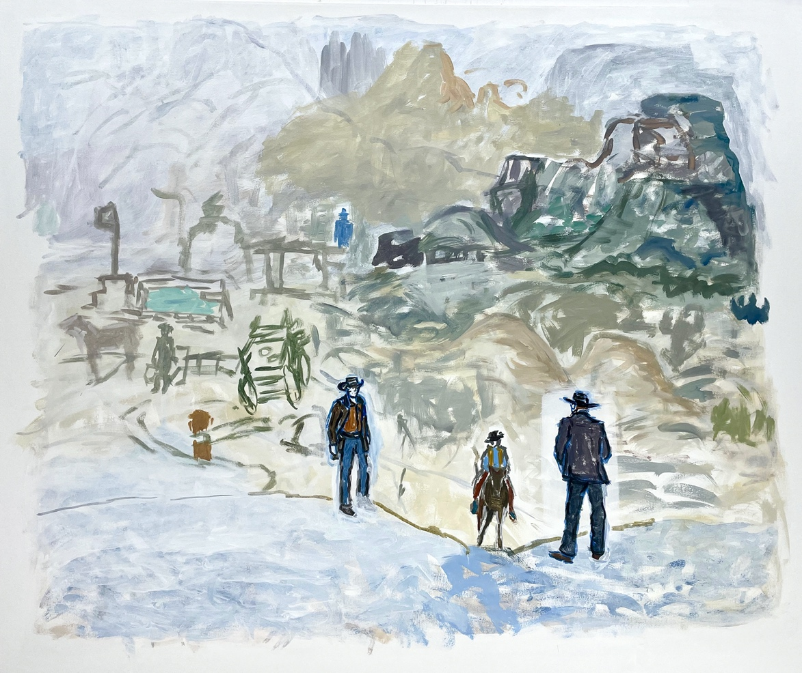

West of Tombstone, 2021, Linda Blackburn, Acrylic on canvas, 50 x 60”

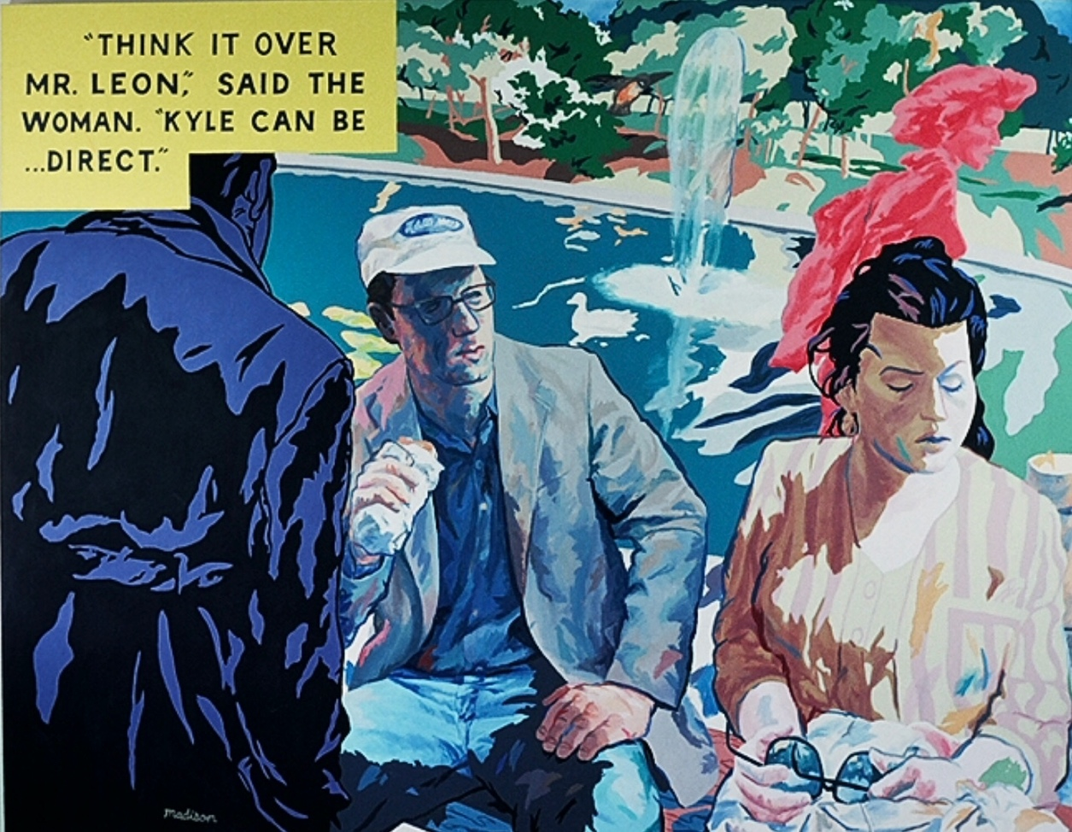

Luncheon on the Grass, 2003, Ed Blackburn, Acrylic on canvas, 78 x 100”

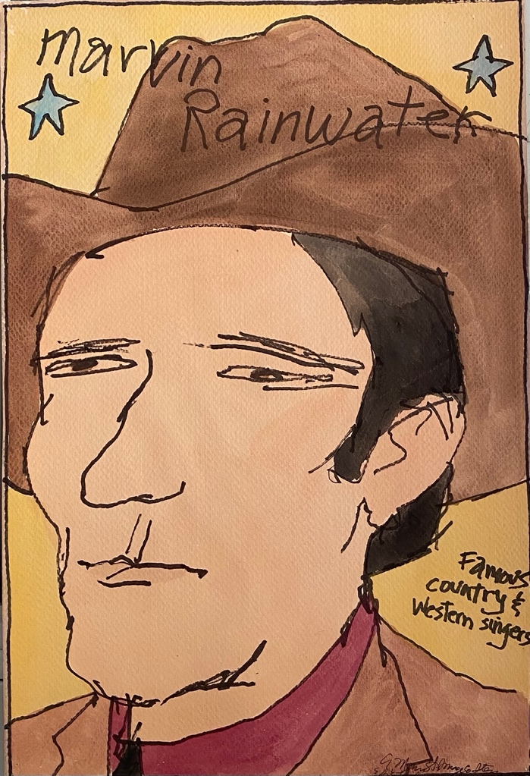

Famous Country and Western Stars: Marvin Rainwater,
Ed and Linda Blackburn, Mixed media, 12 x 17.75

Word document without images available.
For additional information or images, email Natalie Baldin
Natalie@artspace111.com

