Artspace111 Announces Vibrant, Interactive Exhibition for Fall Gallery Night

Paradigm Shift | Ender Martos
September 10 – October 29, 2022
Opening Reception Fall Gallery Night
Saturday, September 10, 2022
12- 9pm

Artspace111 presents Paradigm Shift, by Texan-Venezuelan artist Ender Martos. A paradigm shift is an intense transformative process that lacks a true beginning, middle, and end. Martos’ upcoming show celebrates this concept through a carefully thought-out presentation of curated wall pieces created through the Covid-19 pandemic, as well as a brand new series where the artist explores new materials that help convey a sensation of shifting process and movement. The exhibit will showcase dynamic three-dimensional wall sculptures created with monofilament, colored acrylic mirror and other media.

In the pursuit of elevating our perspectives, Martos’ artworks often call for unchoreographed movement from viewers. As with some of the pieces, motions are reflected and abstracted back at us through acrylic mirror, challenging our ideas of what is actually on display. Although images of the sculptures seem to be computer-generated, a calming sense of naturalness can be found in their unity. In a time where change is the only constant, it is important to acknowledge the unique response that is Paradigm Shift. Visually, Paradigm Shift presents a labyrinth of geometry, precise lines, and vibrant colors. Conceptually, the series asks viewers to change their perspectives and allow a shift of thinking, a practice that we all could apply to our daily lives.

“I have always had an aptitude for design and technical drawing. Growing up, I found satisfaction in crafting perfect lines and geometric shapes while making their presentation clean and accessible. I dropped out of architecture school to become a visual artist. I realized I saw the world through a different lens. My pieces seek to open your mind and heart. I want you to live an active experience as you walk around them. I want this experience to affect your sight, mind, and soul. I want this experience to make you question reality. There is no “best way” to experience my artworks. You can take them for what they are, complex geometric shapes that blend color and mathematics, or you can dig deeper inside their layers and let each line take you to another place within the cosmos of your subconscious.” -Ender Martos

“Paradigm Shift is set apart from other exhibitions because of its innovative and intentional design work. These pieces are thoughtfully created to shift our perceptions and explore our inner selves. Playfully architectural, these works inspire curiosity creating a contemporary space filled with a multi-dimensional spirit.”
– Margery Gossett, Owner Artspace111

About Ender Martos

Ender Martos is an Award-winning artist that resides in Austin, Texas.
He is best known for creating impactful sensory experiences of optical movement that engage the viewer's curiosity and perception. Ender was born in Merida, a city located in the Venezuelan Andes. Ender believes having grown up in one of the most diverse countries on earth had a profound impact on his work. Ender is considered a new representative of the Venezuelan kinetic art movement started by masters Jesus Soto, Carlos Cruz-Diez, Gego and Alejandro Otero. Martos's colorful three-dimensional installations have been celebrated all over the world. His work has been exhibited in Chicago, Mexico City, Monterrey, Miami, Houston, Marfa, Georgetown, Austin, and others. Ender's public art installations have been commissioned by multiple transnational corporations (Facebook/Meta, etc), as well as cities and municipalities. Ender earned a degree in Fine Arts from The University of Texas at Austin. He is currently represented by Ellio Fine Art in Houston, Texas, Carneal Simmons Contemporary Art Gallery in Dallas, TX, Artspace111 in Fort Worth. Ender is managed by Tiburon Transmedia in Austin, TX.

More Happenings at Artspace111 on Fall Gallery Night 2022

In the Great Gallery, Artspace111 presents the group exhibit Nightscapes, debuting new works by Artspace111 represented artists. In addition to the artwork on view, Artspace111 will have music on the patio and a food available for purchase in the evening hours.

About the FWADA Gallery Night
(From the Fort Worth Art Dealerʼs Association Website)
Twice a year, the Fort Worth Art Dealers Association (FWADA) invites you to take in the visual arts and our community’s unique cultural richness during Gallery Night in Fort Worth. Most participants are open from noon to nine. Come take a stroll through participating galleries, museums, retail businesses, and area restaurants, and enjoy the many artists featured during this community event.

About Artspace111
Located in downtown Fort Worth, Texas, Artspace111 specializes in the exhibition of Contemporary Texas Art. In 1980, twin brothers Daniel and Dennis Blagg established Artspace111, converting a historic 1911 building into artist studios and a small gallery space in order to support and celebrate the work of local artists. In 2007, Margery Gossett and William Grella became the Owner/Directors of Artspace111 and further developed the gallery into a celebrated and distinguished 3,000 square foot art gallery. In addition to the year-round schedule of solo and group exhibitions, Artspace111 designs corporate and private art collections for clients throughout the country and hosts special events in its distinctive gallery and sculpture gardens. Artspace111 is dedicated to making contemporary art approachable to individuals of all ages.
______________________________________________________________________________

For additional information or images, email Natalie Baldin
Natalie@artspace111.com

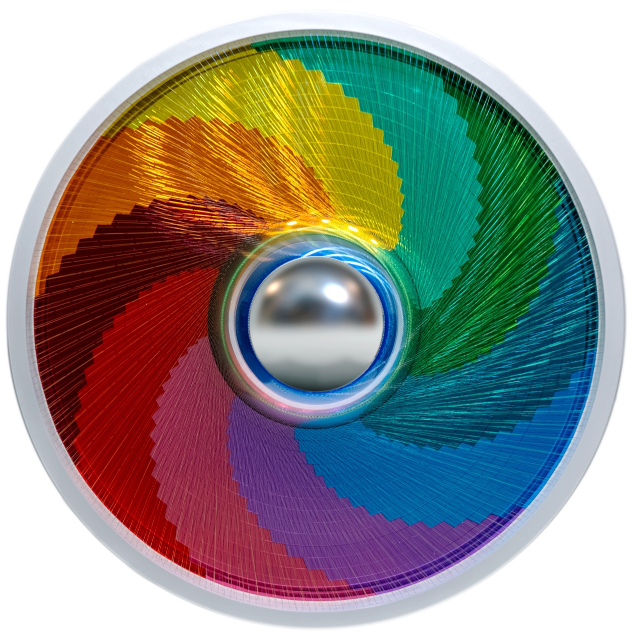

Image (above)| Celestial Rain of Glowing Charm, 50” Diameter x 4.5,” 2022, Mixed media.

Ender Martos Image by Sergio Carvajal-Leoni

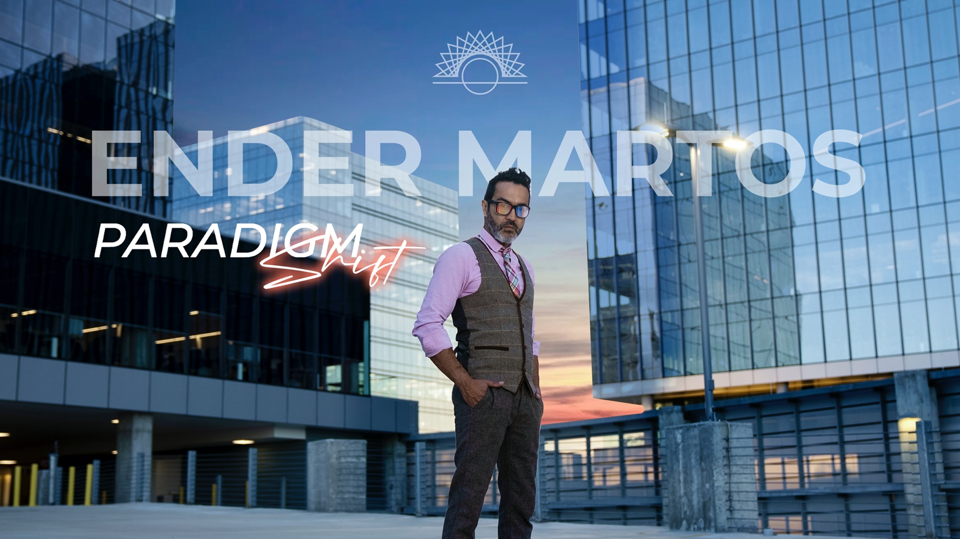

Paradigm Shift Image by Sergio Carvajal-Leoni

