Artspace111 Presents Three New Solo Exhibitions from
May 12 – June 25th

Healing | Mihee Nahm
In the Main Gallery. May 12, 2022 – June 25, 2022

Marking Time | Robert McAn
In the Great Gallery. May 12, 2022 – June 25, 2022

Solo Solo | Jason Bly
In the Solo Solo Space. May 12, 2022 – June 25, 2022

Opening Reception, Thursday, May 12, 2022, from 5-8 pm.

Artspace111 is honored to present three new exhibitions from May 12th through June 25th, 2022. These three exhibitions will all be held at 111 Hampton Street in the 3,000 square foot historic building. Although separate, these exhibitions emphasize the artistic merit in each other.

“These three exhibitions experiment with what defines realism through oil paint. Although different in composition and subject matter, Nahm, McAn, and Bly reveal the extraordinary in everyday life. Through representations that mimic the real and the imagined, the exhibits present us with a reality we experience unconsciously every day.” – Margery Gossett, Gallery Owner and Director of Artspace111
__________________

Healing by Mihee Nahm showcases everyday flora Nahm encounters on daily walks. What Nahm refers to as “marginalized greeneries,” compositions of trees, vines, and domesticated plants fill extremely dense oil paintings. What began as a photographic encounter, quickly turned to a digitally archived collection of interesting subject matter. Formal elements such as color, texture, light, shape, and form are selected and often digitally altered to communicate Nahm’s visual attraction while evoking a sense of longing. Starting with acrylic on a small scale, these images are drawn, and then a few are selected for life-sized renderings in oil. This labor-intensive way of creation emphasizes Nahm’s primary goal of mimesis. Although each individual painting goes through various approaches of fabrication, the consistency of added layers is evident throughout the entire series.

Nahm says, “Layering allows a second chance; rather than expecting it to be perfect the first time, I approach the subject matter slowly and organically in order to get the right value and color. Some days, painting takes on a meditative quality. Other days, it is chaotic. Other days still, it simply feels vague. On rare occasions, painting seems magical, transforming my initial attraction into a physical object.”

About Mihee Nahm
Mihee Nahm was born and raised in South Korea until the age of sixteen when she moved to the United States. In America, she took her first painting class which compelled her to pursue art. Living as a foreigner in America for over a decade pushed her to explore themes of memory, sense of place and nostalgia. Mihee Nahm holds an MFA from the University of Texas at Austin, and a BFA from Art Academy of Cincinnati. Her work has been shown in solo and group exhibitions nationally. She also has attended residencies at the Vermont Studio Center and Brush Creek Foundation. She currently lives and works in Grapevine, Texas.
________________

Marking Time by Robert McAn brings forth the artist’s newest oil paintings and monotypes. This new work continues the artist’s exploration of the intersection between painting and photography. For the exhibition, McAn establishes the canvas ground with painterly photographic imagery. In contrast, the surface layer of the work in oil stick mimics the underlying structure of digital photography with its color blocks and pixels. Rapid and unique hand-painted monotypes are also exhibited as multiple and individual artworks.

Regarding his practice and new work, McAn says, “After printing painterly photographs on canvas, I then apply oil stick in color blocking and pixel patterns. This combination of techniques highlights and magnifies the significance of foreground and background in visual representation. The work in Marking Time is also influenced by the early stages of the pandemic. During isolation and home-bound, my repeated visuals were hanging family quilts and monotypes I created in high school. Late-pandemic creativity now explores a new type of image quilting and technique weaving and a newfound love for the creative freedom of monotypes."

About Robert McAn
McAn holds a Master of Fine Arts degree in painting and photography from the University of North Texas, and a Bachelor of Arts degree from North Texas State University. McAn is Head of Donor Relations, Membership, and Special Events at the Kimbell Art Museum (since 1994). He was assistant director of Barry Whistler Gallery in Dallas and president of 500X Gallery in Dallas from 1991-to 94. In addition, he served as an adjunct professor of photography at Austin College in Sherman, Texas (1993-1994). His work has been widely exhibited and is included in public and private collections worldwide. He lives and works In Fort Worth, Texas.
________________

Solo Solo is an exhibition space awarded to the winner of the prior year’s Annual Texas Juried Exhibition. In 2021, Jason Bly’s oil on panel painting titled Suspension of Disbelief, won first prize. Through detailed surrealist paintings, Bly’s work examines the mundane through the lens of past predictions of the future dating from the 1950’s-1980’s. These forecasts found in scientific journals and science fiction, saw beyond the year 2000 to a variety of outcomes, whether hopeful or fearful of the future. These forecasts predicted space travel, new technologies, and stable life, while others predicted darker futures of nuclear annihilation, fear of the unknown, and a lack of natural resources.

Bly states, “I am interested in portraying these fantastic events alongside painted representations of everyday household items that act as symbolic tokens and serve as access points to the intangible.”

About Jason Bly
Jason Bly resides in Wichita Falls, TX. He is Assistant Professor of Art at Midwestern State University where he has taught painting and drawing since 2017. He also serves as a member on the board of the Texas Association of Schools of Art. His previous experience includes teaching at Southern Illinois University Edwardsville (2007-2017) and Lewis and Clark Community College (2007-2017). Bly also served as Director of Exhibitions at the Edwardsville Arts Center (2013-2017). His paintings have been shown in solo, invitational, and juried exhibitions. He holds his MFA in painting from Southern Illinois University Edwardsville and MA and BA degrees in painting and printmaking from Eastern Illinois University.
Artspace111 will be open on Thursday, May 12, 2022, from 5-8pm. This reception will provide an opportunity for guests and patrons to meet and visit with the artists. The gallery requests that guests RSVP via Eventbrite. Social distancing and wearing masks inside the gallery is highly encouraged.

Link to RSVP here:

About Artspace111
Located in downtown Fort Worth, Texas, Artspace111 specializes in the exhibition of Contemporary Texas Art. In 1980, twin brothers Daniel and Dennis Blagg established Artspace111, converting a historic 1911 building into artist studios and a small gallery space in order to support and celebrate the work of local artists. In 2007, Margery Gossett and William Grella became the Owner/Directors of Artspace111 and further developed the gallery into a celebrated and distinguished 3,000 square foot art gallery. In addition to the year-round schedule of solo and group exhibitions, Artspace111 designs corporate and private art collections for clients throughout the country and hosts special events in its distinctive gallery and sculpture gardens. Artspace111 is dedicated to making
contemporary art approachable to individuals of all ages.

Word document without images available.
For additional information or images, email Natalie Baldin
Natalie@artspace111.com

Accompanying artwork image information:

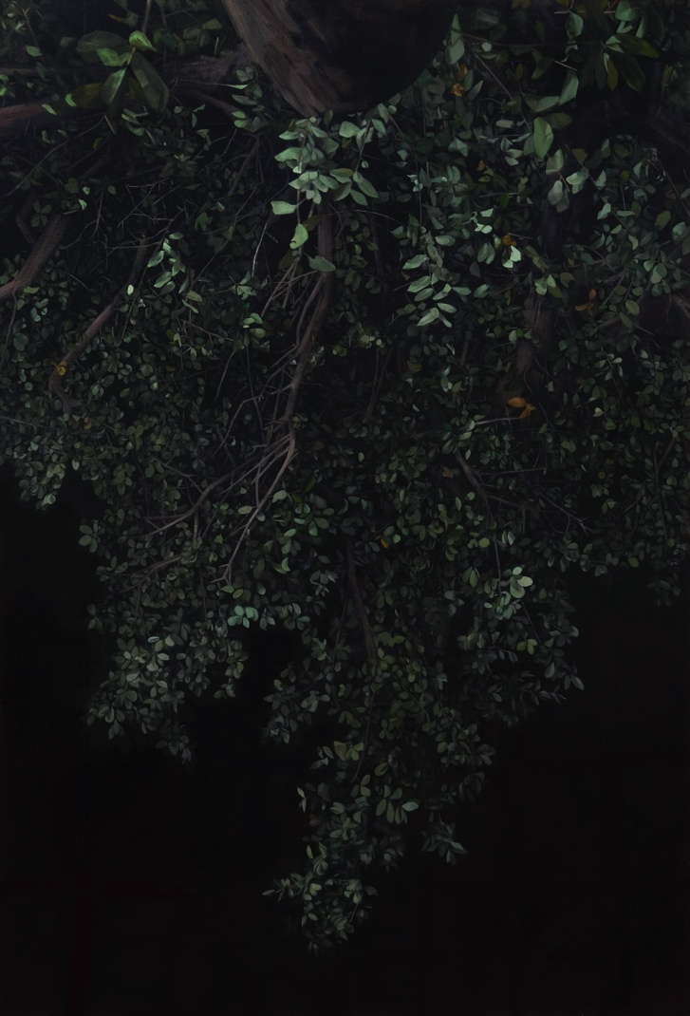

Night Walk #3, Mihee Nahm, 2022, oil on canvas, 60 x 40”

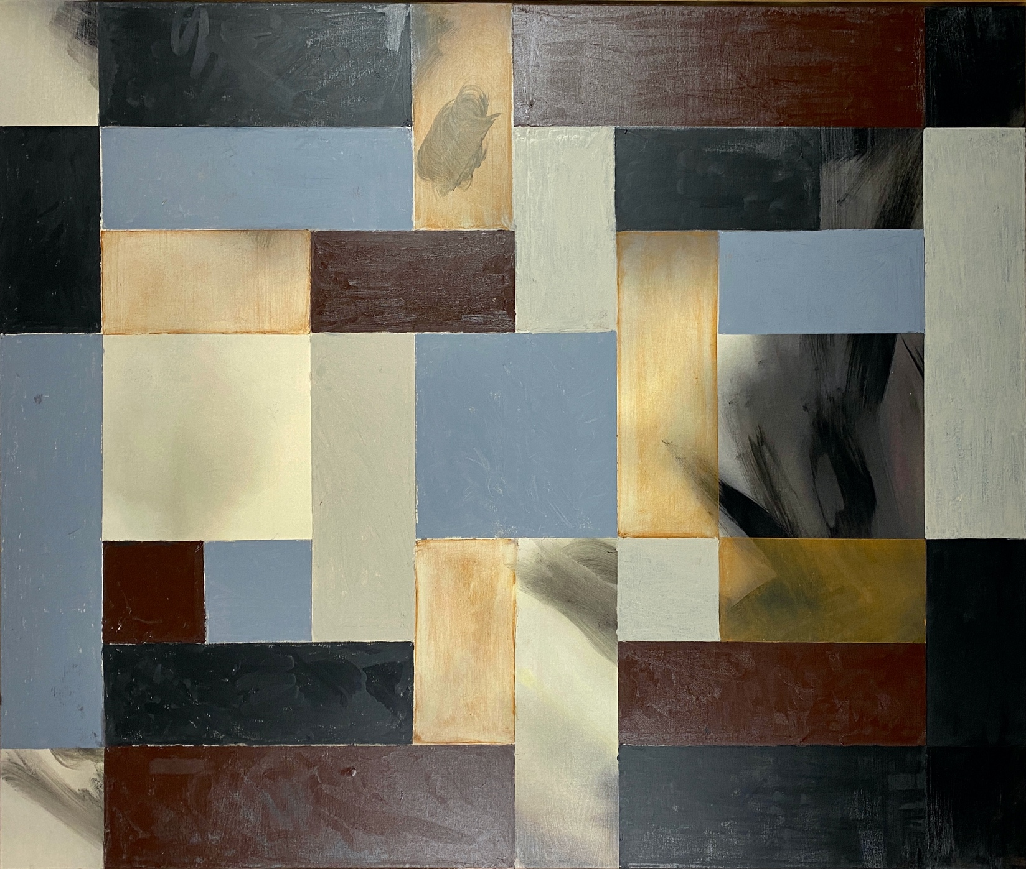

Autumn Wind, Robert McAn, 2022, Mixed media on canvas, 45 x 50”

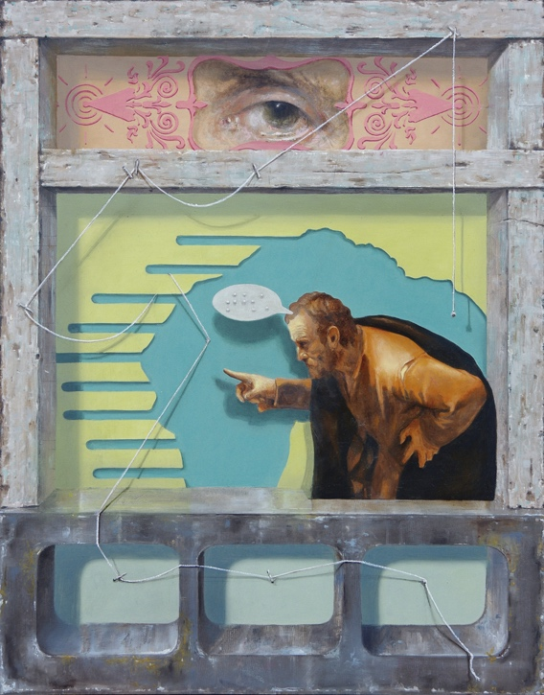

Suspension of Disbelief, Jason Bly, 2020, Oil on panel, 14 x 11”

