Artspace111 Presents new artworks by Blagg and Gentling in new exhibition

Town & Country | The Art of Douglas Blagg and Suzanne Gentling
October 29, 2021 – December 4, 2021

Opening Reception Thursday, November 4th
5 - 8pm

Artspace111 presents Town & Country: The Art of Douglas Blagg and Suzanne Gentling. Both from important North Texas artist families, Douglas Blagg, and Suzanne Gentling offer opposite views of the Texas landscape in the realist tradition. Blagg’s work focuses on urban landscape through watercolor with a high attention to detail and use of vibrant color. Gentling guides the viewer in another experience, showing gentle traditional countryside through watercolor, pastels, photography, and lithographs. Both artists use the vehicle of landscape to meditate on the mysteries of the world that surrounds them.

“Witty details from urban landscapes juxtapose observations from country living, including vast landscapes, skyscapes, and details of Texas flora in this exhibition. Both Blagg and Gentling’s works provide a quiet comment on life’s little moments, and ask for our attention with them.“ – Margery Gossett, Gallery Owner, Artspace111

Artspace111 will host an artist reception on Thursday, November 4, 2021 from 5-8pm. This reception will provide an opportunity for guests and patrons to meet and visit with the artists. The gallery requests that guests RSVP via Eventbrite.
Link here: https://www.eventbrite.com/e/town-country-opening-reception-tickets-178276579047

About Douglas Blagg
Douglas Blagg is the youngest painter of the noted artists brothers, the Blagg’s,
Doug was tutored from a very early age in all mediums of fine art, drawing, watercolor, and oil painting.
Primarily a watercolorist Doug has spent many years rendering Los Angeles noir, landscapes, architecture, and people. His work is featured in many significant private collections, as well as several museums.

In 1980 with brothers Daniel, Dennis and Woodrow, Doug joins them in co-founding Artspace111, exhibiting throughout the next four decades. In 1982 with artist Nancy Lamb, they open open Huzzo-Blamb Gallery in Fort Worth, showcasing emerging and noted contemporary Texas artist. 1984, Doug relocates to Los Angeles, establishing a dual career in the film world as well as exhibiting widely in several galleries, including Robert Berman in Santa Monica. Now an established curator, Doug co -founds Modern Objects Gallery featuring new Los Angeles artists. Numerous shows in both California and Texas culminating in a Blagg brothers exhibit at the Old Jail Museum in Albany Texas, 2004. In 2010 founding artist at Westmoreland Lofts Inner City Arts Group. Curating numerous exhibitions, Doug receives citation of achievement from the mayor of Los Angeles and city council. Retiring from the film industry after 35 years, returns home to Texas, and returns to a career as a full-time painter.
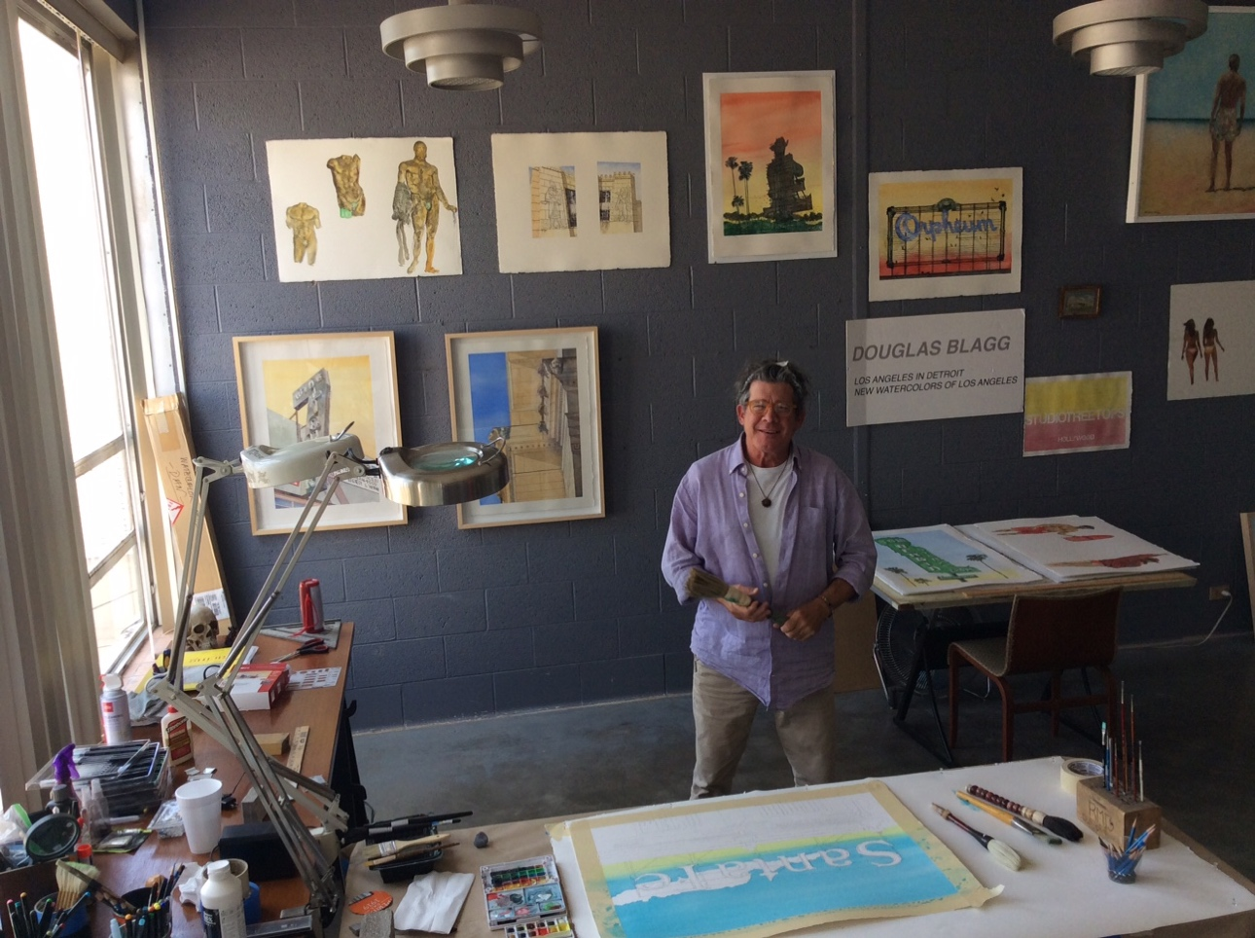
Douglas Blagg in his studio at the Fort Worth Community Arts Center.

About Suzanne Gentling
Suzanne Gentling, the youngest of four siblings, grew up in Fort Worth, Texas, and began drawing and painting in the mid-1960s while still in high school. Initially working in pencil and watercolor, she later added pastel and oil to her media, as well as photography.
After obtaining a B.S. degree in Medical Laboratory Science from the Medical College of Georgia in 1969, she lived in New Orleans for four years before moving to rural Jefferson County, MS., in 1974. Here she spent the next ten years drawing, painting, and gardening before returning to Texas in 1984, where she currently resides on a small, rural property in Somervell County. From 1999 to 2002, she entered the graduate program at TCU where she earned her MFA in Painting.
Although the focus of her work has been primarily on the landscape, she produced a series of sixty architectural portraits from the Vicksburg to Natchez area during her time in Mississippi and has experimented with traditional and digital printmaking as well. Her works are in numerous private collections across the country and abroad.

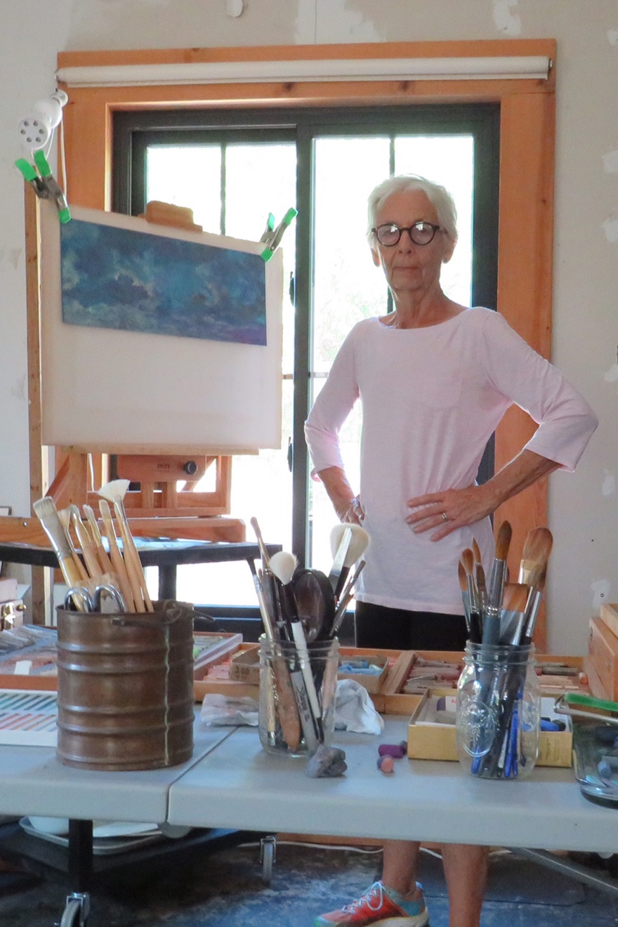
Suzanne Gentling in her studio.

About Artspace111
Located in downtown Fort Worth, Texas, Artspace111 specializes in the exhibition of Contemporary Texas Art. In 1980, twin brothers Daniel and Dennis Blagg established Artspace111, converting a historic 1911 building into artist studios and a small gallery space in order to support and celebrate the work of local artists. In 2007, Margery Gossett and William Grella became the Owner/Directors of Artspace111 and further developed the gallery into a celebrated and distinguished 3,000 square foot art gallery. In addition to the year-round schedule of solo and group exhibitions, Artspace111 designs corporate and private art collections for clients throughout the country and hosts special events in its distinctive gallery and sculpture gardens. Artspace111 is dedicated to making contemporary art approachable to individuals of all ages.

Accompanying artwork image information:

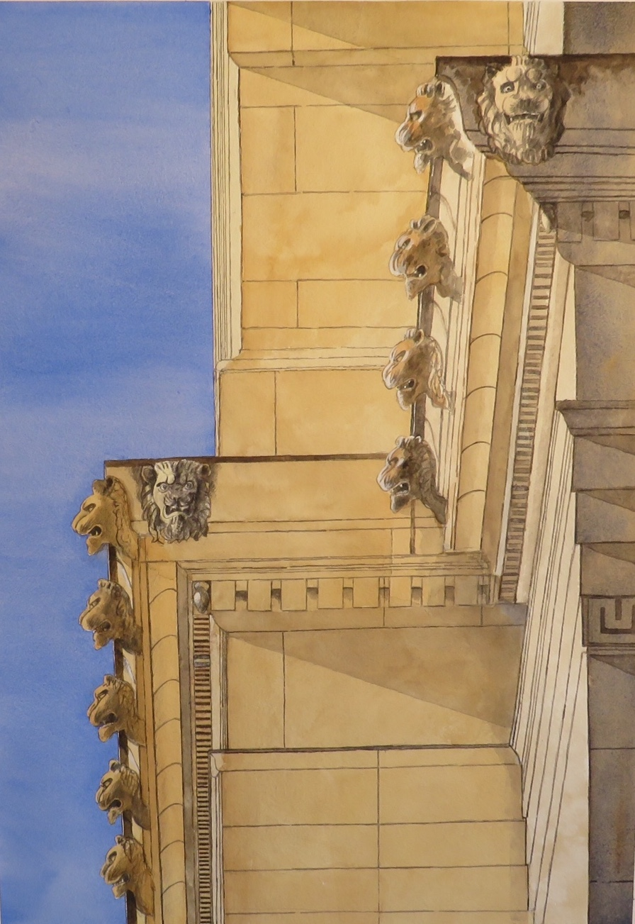

Post Office, Douglas Blagg, Watercolor on paper, 26 x 32”

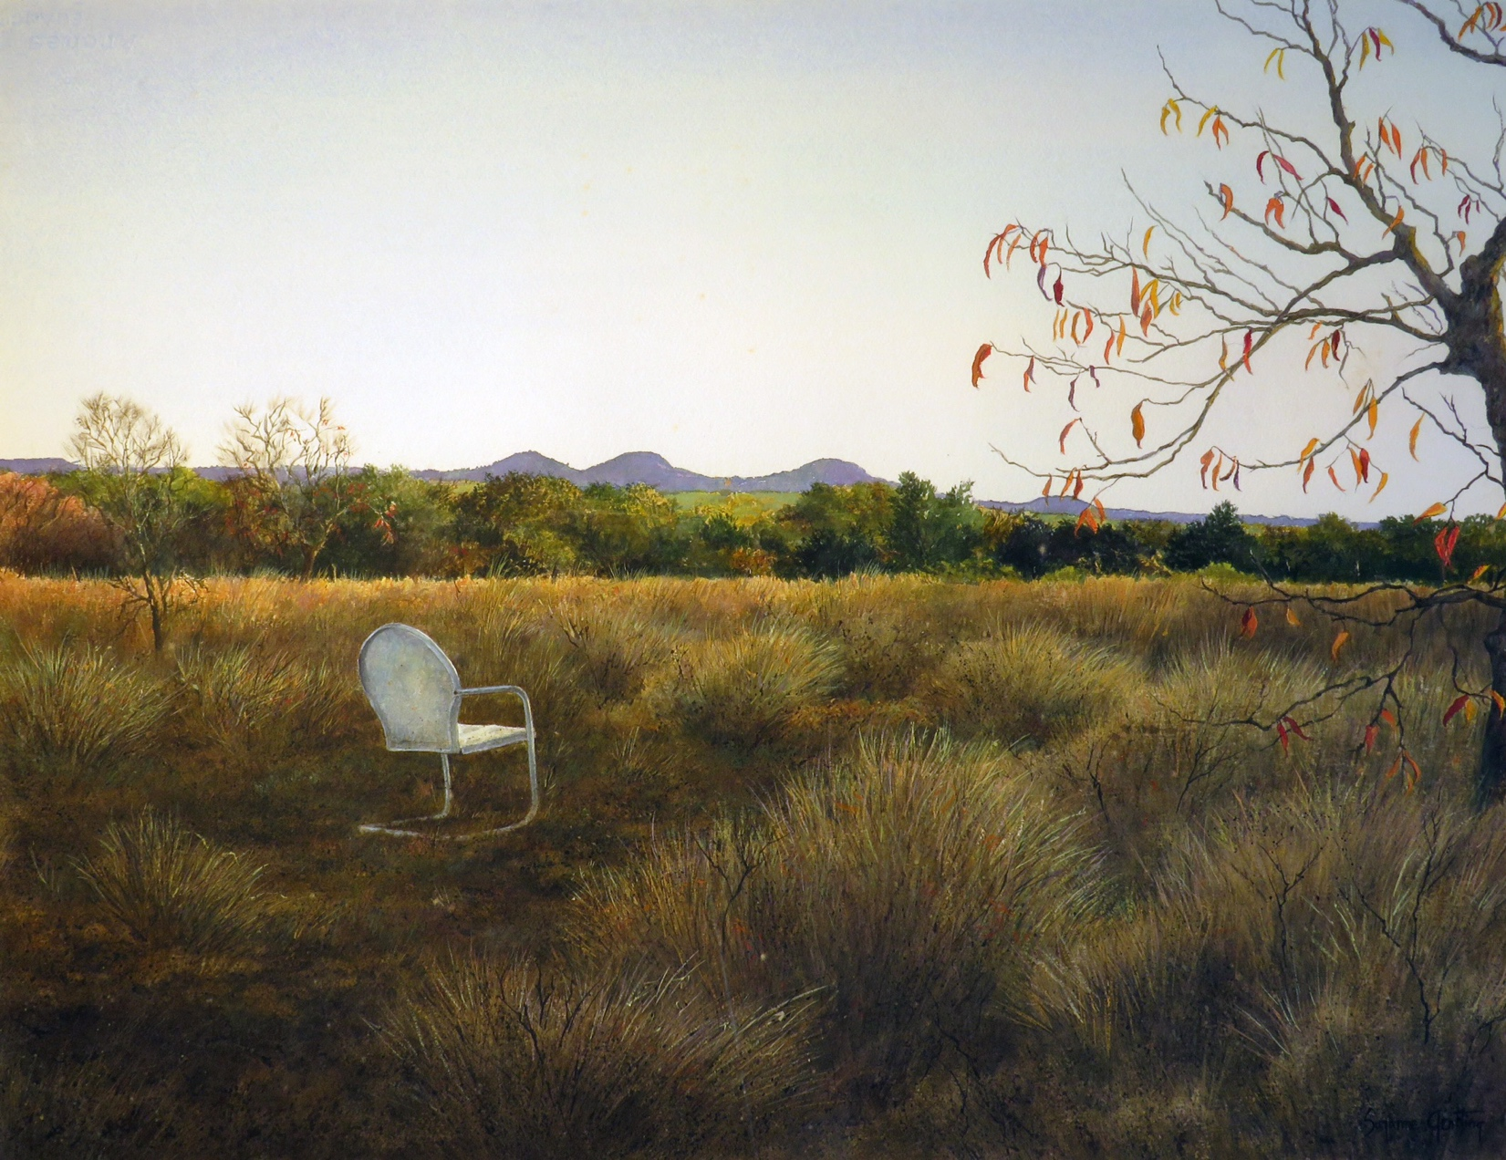Solitaire, Suzanne Gentling, Watercolor on D’Arches, 22 x 30”

Word document without images available.
For additional information or images, email Ariel Davis
ariel@artspace111.com

