Artspace111 Announces New Solo Exhibition for Fall Gallery Night 2021

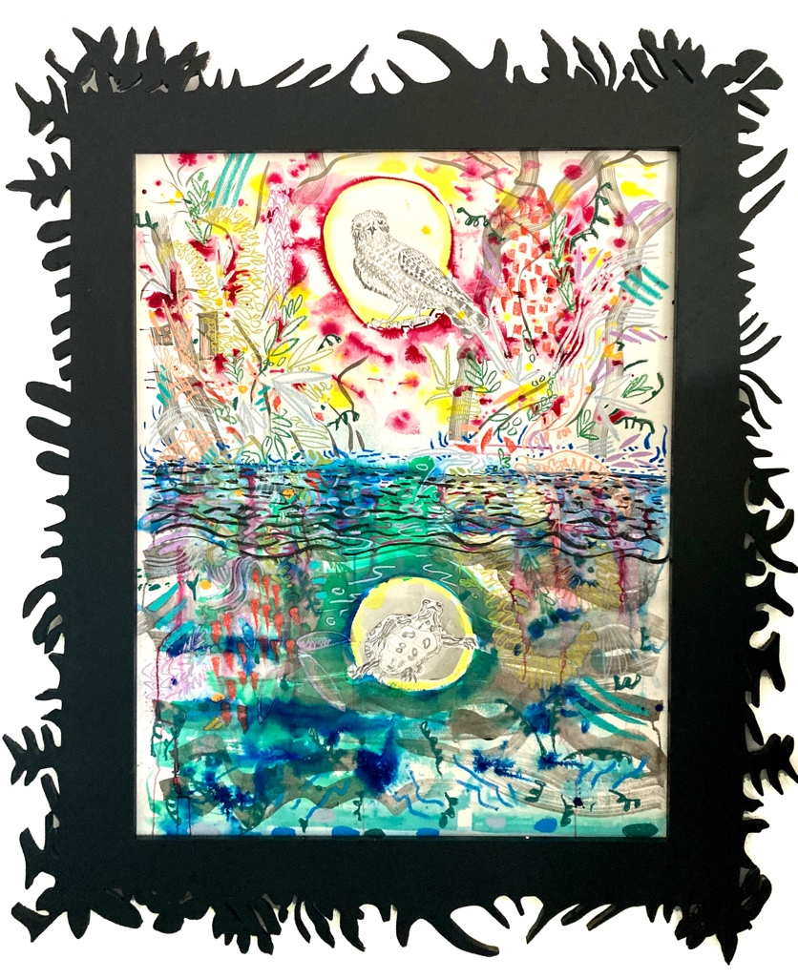
Swallow the Frog | Jules Buck Jones
September 11 – October 23, 2021
Opening Reception Fall Gallery Night
Saturday, September 11, 2021
12- 9pm

Artspace111 presents Swallow the Frog, the first solo exhibition of works by Jules Buck Jones in Fort Worth. In Swallow the Frog, Jones presents a wide range of drawings and paintings expanding on the artist’s interests and concerns with the natural world. The exhibit will showcase monumental works on paper like Serpent of Summer, where Jones employs his heavily stylized use of watercolor, ink and pastel to create a scene writhing with motion and light.
Other works in the show pivot away from the loud and expressive as in “Eye In The Sky”, a softer, quieter graphite drawing of ancient and modern amphibians alongside the moon, which operates as a study in textures while highlighting leaps in biological evolution. More still, he’ll be showing several large-shaped wood panels like “It’s Hard To Forget What You Don’t Know” and “Swallow The Frog” where Jones relies on the hard edge of his panel to be the descriptive driver of the work, allowing his use of paints and pastels to embrace a more suggestive role. In this exhibit Jones reveals a multifaceted relationship to drawing, one where deliberate, descriptive modes inhabit the same space as the bold and expressive. The range of styles, reflects the artist’s goal to create work that is both celebratory and mournful, straddles fact and fiction, and explores hope, excitement, and despair.

Image (above)| Honeysuckle, Jules Buck Jones, Watercolor, graphite, pastel, and ink on paper, 54 x 44”, 2021
“My artwork is a direct reflection of my relationship with, and thoughts on nature. Paintings and drawings are concocted from a mixture of direct experience, research, and imagination. My work depicts abstracted flora and fauna, anthropomorphized landscapes, and conflated geologic timelines presenting synchronicities in nature, and twisted narratives of natural history. I strive to create work that celebrates the marvels of the natural world, while also addressing the imbalance and degradation of this planet’s natural treasures. The work leans heavily on drawing, dense patterns, layering, expressive mark making, and collage. While works on paper are my primary vehicle, I produce artwork in many forms including sculpture, video, performance, and installation.” – Jules Buck Jones

Image (above) | Honeysuckle (Detail), Jules Buck Jones, Watercolor, graphite, pastel, and ink on paper, 54 x 44”, 2021

“Jules Buck Jones creates work that is exuberant, bold, playful, and accessible. He is addressing current environmental issues through familiar and beautiful wildlife imagery. We believe his show is the perfect immersive experience for our return to a normal Fall Gallery Night celebration and look forward to introducing Jules Buck Jones to Fort Worth.”
– Margery Gossett, Owner Artspace111
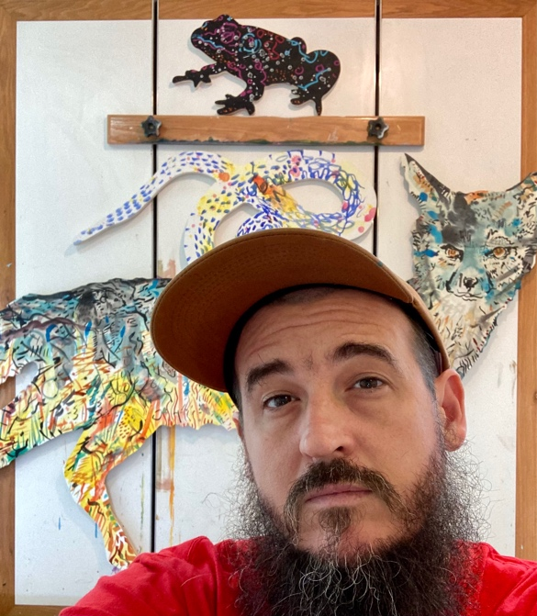
About Jules Buck Jones
Jules Buck Jones creates art inspired by the mechanics and mysteries of the natural world. His body of work ranges from dense, organic watercolors and drawings, to large-scale performances employing costumes and puppetry. He is a founding member of the collective, non-profit, MASS Gallery and the art / science collective Animal Facts Club, both located in Austin TX. Jules has participated in art residencies including Skowhegan School of Painting and Sculpture, Vermont Studio Center, Arrowmont, The Lighthouse Works, and The Everglades National Park. He shows extensively throughout TX with solo shows in Austin, Dallas, Beaumont, Ft. Worth and Houston. Jules currently teaches drawing at TX State University in San Marcos, TX.

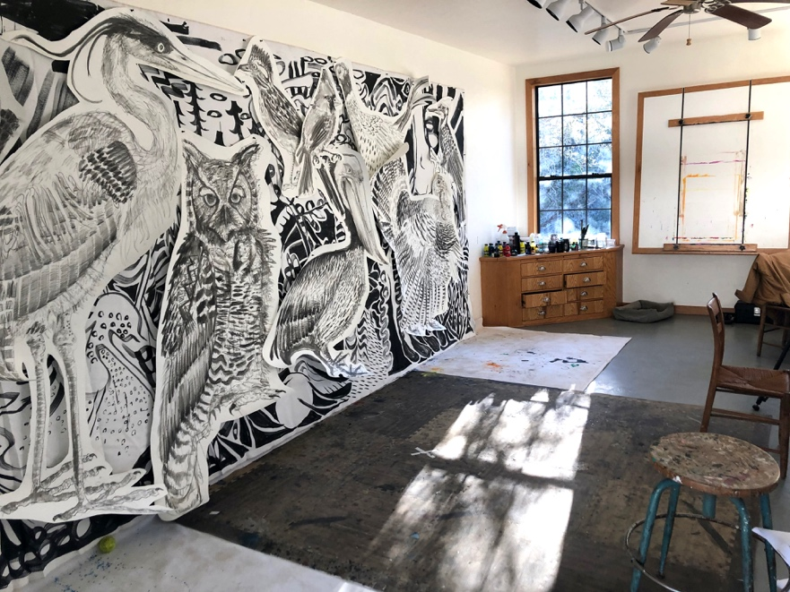
The Artist’s studio in Wimberley, Texas

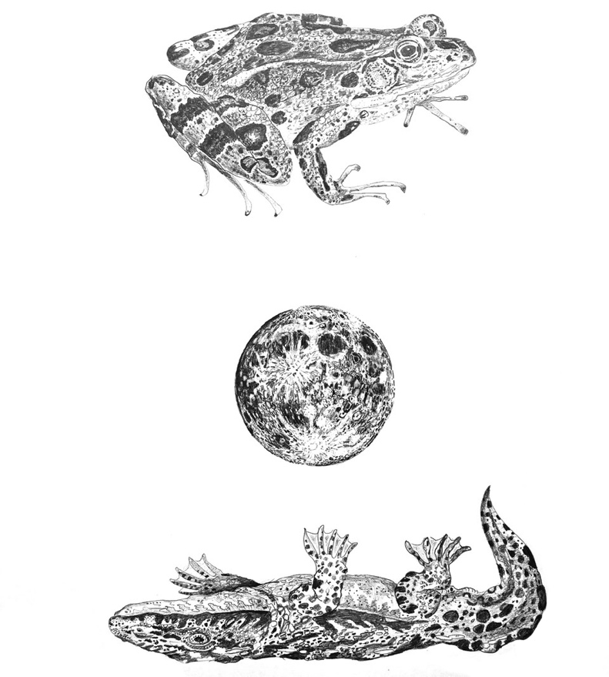

Image | Eye In The Sky, Jules Buck Jones, Graphite on paper, 40 x 50” 2021

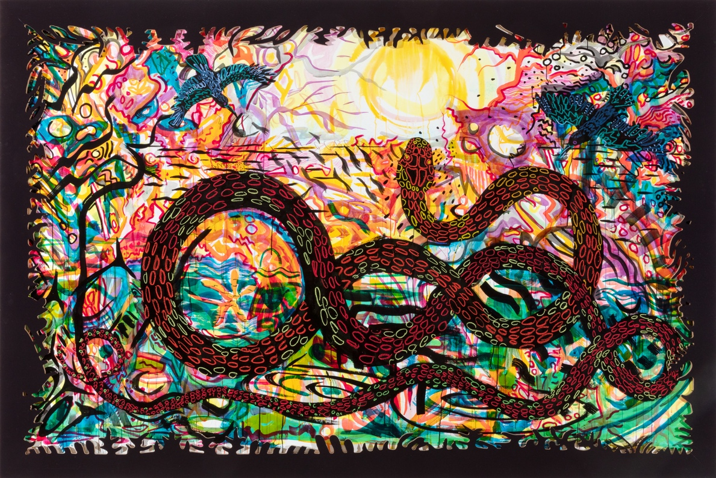

Image | Serpent of Summer, Jules Buck Jones,
Watermedia on paper with cutout frame, 72 x 110” 2021

More Happenings At Artspace111 on Fall Gallery Night 2021

Alongside Swallow The Frog, Artspace111 and the Texas Sculpture Group present the first collaborative show of outdoor sculpture installations from members of the Texas Sculpture Group. This new collaborative series between the Artspace111 and the Texas Sculpture group aims to bring new works to from the Texas Sculpture Group to Fort Worth each gallery night.

In the Great Gallery, Artspace111 presents a group exhibit debuting new works by Artspace111 represented artists. In addition to the artwork on view, Artspace111 will have music in the on the patio and a food available for purchase from a local food truck in the evening hours.

About the FWADA Gallery Night
(From the Fort Worth Art Dealerʼs Association Website)
Twice a year, the Fort Worth Art Dealers Association (FWADA) invites you to take in the visual arts and our community’s unique cultural richness during Gallery Night in Fort Worth. Most participants are open from noon to nine. Come take a stroll through participating galleries, museums, retail businesses, and area restaurants, and enjoy the many artists featured during this community event.

About Artspace111
Located in downtown Fort Worth, Texas, Artspace111 specializes in the exhibition of Contemporary Texas Art. In 1980, twin brothers Daniel and Dennis Blagg established Artspace111, converting a historic 1911 building into artist studios and a small gallery space in order to support and celebrate the work of local artists. In 2007, Margery Gossett and William Grella became the Owner/Directors of Artspace111 and further developed the gallery into a celebrated and distinguished 3,000 square foot art gallery. In addition to the year-round schedule of solo and group exhibitions, Artspace111 designs corporate and private art collections for clients throughout the country and hosts special events in its distinctive gallery and sculpture gardens. Artspace111 is dedicated to making contemporary art approachable to individuals of all ages.
______________________________________________________________________________

For additional information or images, email Ariel Davis
ariel@artspace111.com

