Love Texas Art Gallery Announces Monumental Antonio Lechuga Exhibition

Fences | Artwork of Antonio Lechuga
May 21 – July 17, 2022
Opening reception: Saturday, May 21, 2022 5-8pm
Located at 501 Houston Street, Fort Worth, Texas 76102

RSVP Link here: https://www.eventbrite.com/e/325260301317

Love Texas Art is honored to present Fences, a solo exhibition of works by Dallas based artist, Antonio Lechuga from May 21 – July 17, 2022. The exhibition will be on display at the new Love Texas Art gallery located at 501 Houston Street, Fort Worth, Texas 76107, with an opening reception on Saturday, May 21, 2022 from 5-8pm. The opening reception coincides with gallery openings at Bale Creek Allen Gallery and Dang Good Candy in Sundance Square on May 21.
Fences by Antonio Lechuga showcases sculpture and paintings that depict the architectural fence pattern transforming and using the fence structure as a metaphor to discuss immigration issues along the Mexican American border. His vibrant and colorful new works reimagine the symbol of the fence, utilizing it in protest that focuses on unity and healing. Lechuga wraps his latticework structures with vivid “Cobijas”, enveloping the usually cold, unloved fences in warmth, comfort and security. In addition to the sculptures, Fences will include paintings that accompany and inform the large-scale three-dimensional works.
“Like any fence these simple architectural elements are used to divide space, and as a result, people, environment and create harsh borders. However, instead of monolithic, seemingly unapproachable walls these works are instead large, tall fences of softness. These structures of softness and color provide a sense of security, they offer warmth and they offer comfort. They offer these things in replacement of their opposites: Hard, cold structures used solely for division.“ – Antonio Lechuga
“Over the past 10 years, I have witnessed Lechuga’s art practice grow and develop. He is using his training and knowledge of architecture to create highly sophisticated, playful, meaningful work, and his move into sculpture with this series feels like a natural progression. Margery Gossett and I are honored to debut Antonio’s new series in Fort Worth at Love Texas Art.” – Ariel Davis, Owner, Love Texas Art

Love Texas Art will host an opening reception on Saturday, May 21, 2022, from 5-8pm. This reception will provide an opportunity for guests and patrons to meet and visit with the artist. The gallery requests that guests RSVP via Eventbrite. Social distancing and wearing masks inside the gallery is highly encouraged.

About Antonio Lechuga

Antonio Lechuga is a multidisciplinary artist who was born [1985] in and raised in the Oak Cliff neighborhood of Dallas, TX. Lechuga currently lives and works in Dallas, TX. He attended Southern California Institute of Architecture ( SCI-Arc ) in Los Angeles, CA. Primarily a painter, Lechuga started creating sculpture in 2021.

About Love Texas Art
Located in downtown Fort Worth, Texas, Love Texas Art is an art gallery and art lounge. Featuring over 3500 square feet of exhibition space to display independent contemporary Texas Artists in rotating exhibitions, in addition to a constant display of Artspace111 represented artists. As an extension of Artspace111, Love Texas Art is also dedicated to making high quality contemporary art approachable to individuals of all ages, and offers a gallery shop featuring small original works, prints and art collectibles. Founded in 2022 by Ariel Davis and Margery Gossett, Love Texas Art also seeks to support North Texas Artists with a limited residency studio program in connection to the art gallery, opening Summer 2022. This program will allow the public to directly interact with local artists through studio visits, artist talks, and workshops.

Accompanying artwork image information on the following page:

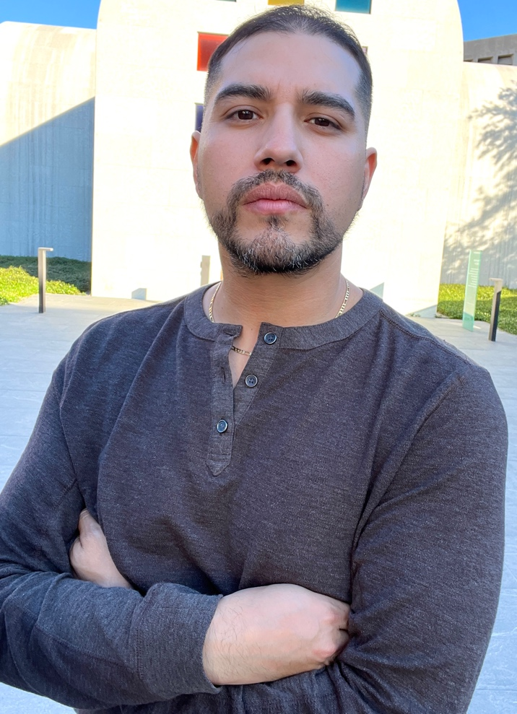
Antonio Lechuga

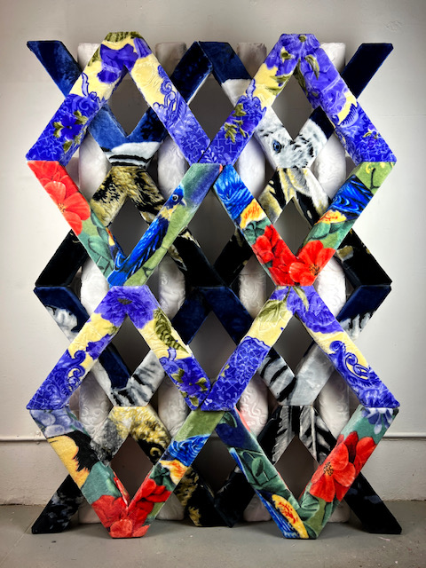
Fence #1, Antonio Lechuga, 2021, Fabric and Foam, 87 x 63 inches

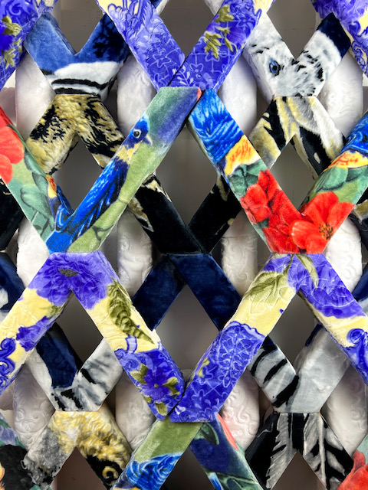

Fence #1 (detail), Antonio Lechuga, 2021, Fabric and Foam, 87 x 63 inches

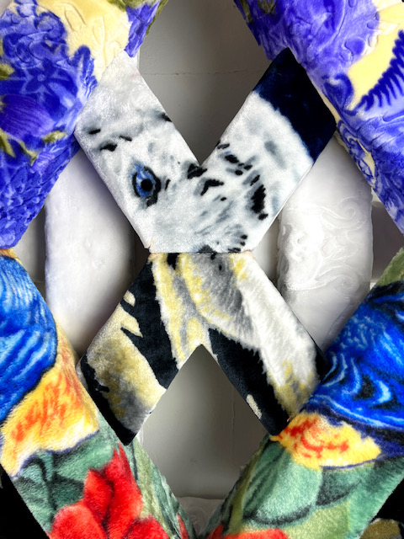

Fence #1 (detail), Antonio Lechuga, 2021, Fabric and Foam, 87 x 63 inches

Word document without images available.
For additional information or images, email Ariel Davis.
Ariel@artspace111.com or art@lovetexasart.co

