A Space Between Time | Carly Allen-Martin and Jim Woodson

Opening Spring Gallery Week | March 27 – April 3, 2021
On Display | March 27 - May 8, 2021

The Art of the Mentee and Mentor; A Celebration of Art Lineage.

Artspace111 is pleased to present the two-person exhibition, A Space Between Time, featuring new large-scale artwork by Carly Allen–Martin and Jim Woodson. This exhibition underscores the mutual transference of creativity and inspiration that is inherent to the teacher/student relationship. As a professor of art at Texas Christian University for 39 years, Jim Woodson created a path for young artists through technical training, spiritual guidance, and by the example of a prolific career which includes being honored as the Texas State Visual Artist. As Woodson’s student, Carly Allen-Martin used these tools to further develop a path that Woodson pioneered, resulting in her own prolific practice that is prized in private collections across the world. A Space Between Time conveys the cultivation of techniques, ideals, correlations and juxtapositions of teaching and discovery.

Jim Woodson on Carly Allen- Martin

In reference to A Space Between Time Woodson says, “One can learn to become an ‘artist’. A teacher can provide some feedback and encouragement but the desire to persist must come from each individual. Sometimes the best thing a teacher can do is to get out of the way, releasing the student to pursue their own path. A ‘good teacher’ can communicate, by example, their own passion. Carly Allen entered my advanced painting class along with about a dozen other students. About half of those exhibited a certain seriousness about painting and a couple of those about becoming ‘a painter’. Carly was one of those. I have been fortunate over the years that a number of past students have continued to stay in touch with me. Of course the ones that have, are the ones that continued to pursue the life of an artist. Many have produced a significant body of work and have found success. Carly is clearly among those. She has established a personal voice that resonates with light, color, and surface. She is simply one of the best.”

Carly Allen–Martin on Jim Woodson

In regards to A Space Between Time Allen-Martin states, “ I have always had a fascination with outlaws. To me an outlaw is a true original. Outlaws never lose the originality of their character and are fearless in their ability to be themselves. They're able to carry a true expression, undeterred by what the world asks them to be. I knew Jim Woodson was an outlaw the first time I met him. He is kind and authentic and carries a mysticism in his persona. Anyone fortunate to study under Jim knew his signature uniform - denim jeans, denim shirt, a black leather vest, and black shoes - always with a braided ponytail down his back. He is someone that has mastered the art of minimizing insignificant details to maximize the details of importance. As a painter, he taught me to look for ways to present details in new light, to be a painter's painter and pull through layers that might have been insignificant before but add to the history and character of a painting. I remember one time in 2005, I went into Jim's office with tears in my eyes. I asked the question that all artists ask themselves from time to time... ’Jim, do you think I'm any good as a painter?’. He looked at me and said ‘Carly, just go make some God damn paintings.’ I now realize that is the answer of a master, and the only answer that will serve you as a creative.”

Images, bios and artist statements below:

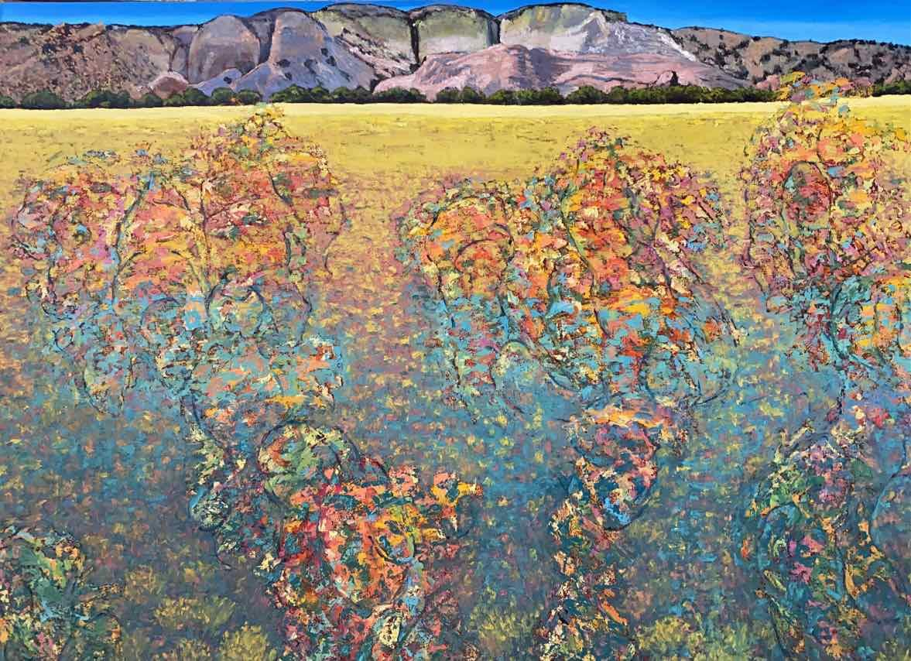
Compelling Embedded Emergence, 2020, Jim Woodson, Oil on Canvas, 36 x 48”

Memories and Muses by Carly Allen-Martin, 2021, Oil on paper, 58 x 66”
_________________________________________________________________

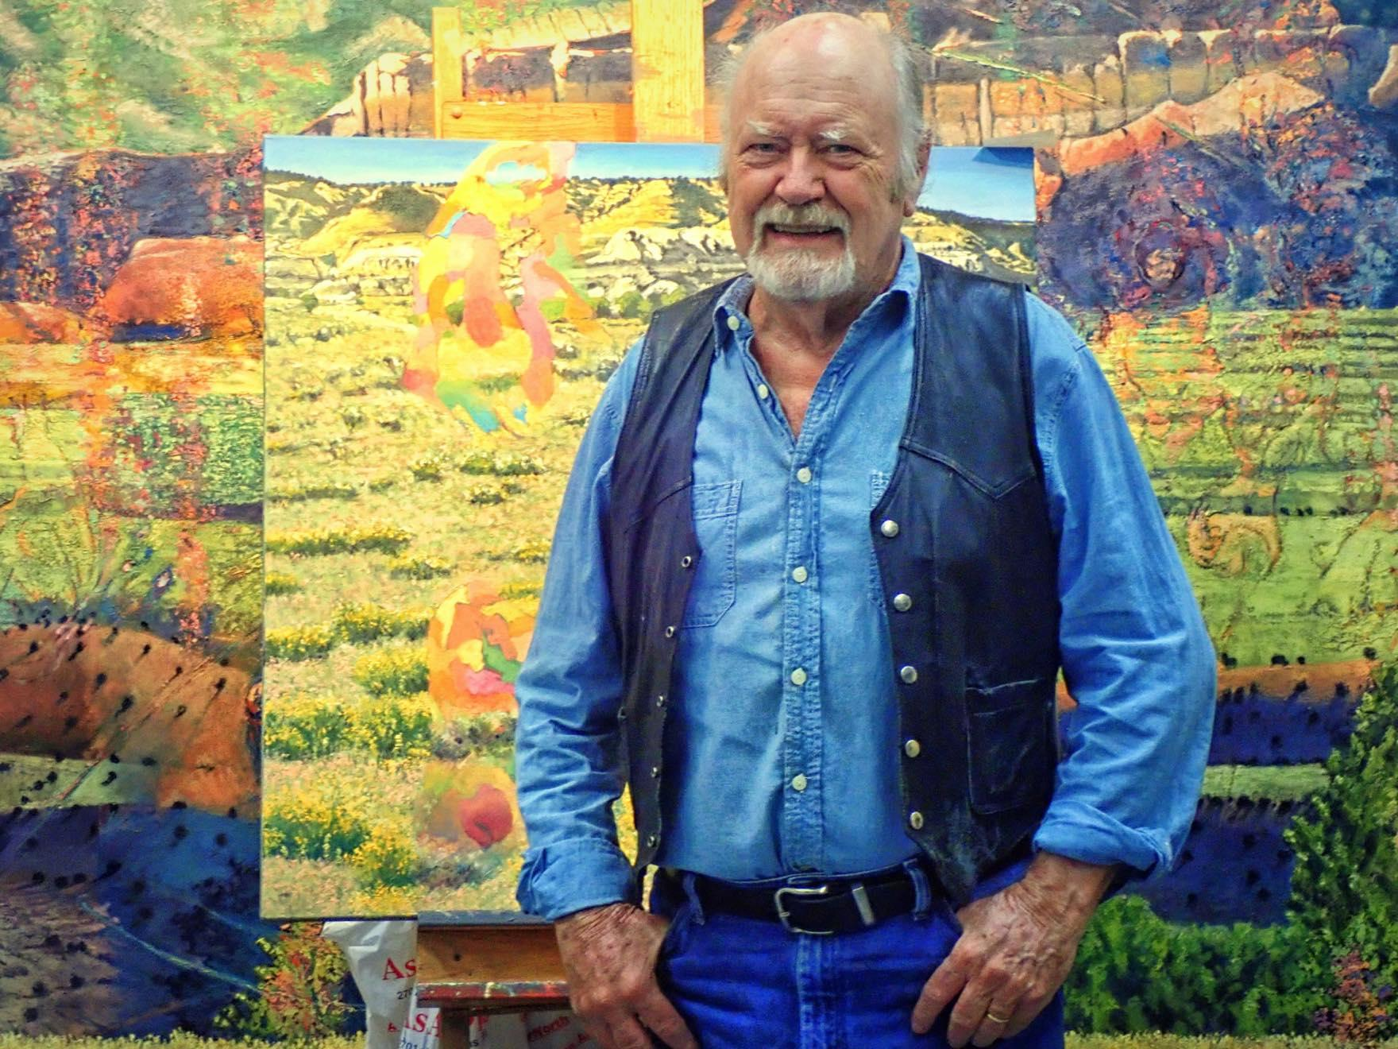
Jim Woodson at his studio in front of his work.

About Jim Woodson’s Work

Interested in calling attention to the act of painting, as well as to how one understands visual conventions by combining self-referential marks and forms with more traditional rendering, Jim Woodson explores the high deserts of New Mexico in this body of work. The contrasts enliven the surfaces and create an ambiguous space that causes the viewer to question their notions about perceptual space. With these works, it is Woodson’s hope to provide the viewer choices that lie between dualities such as cultural and natural, near and far, mythic time and geologic time.
_____________________________________________________________________________

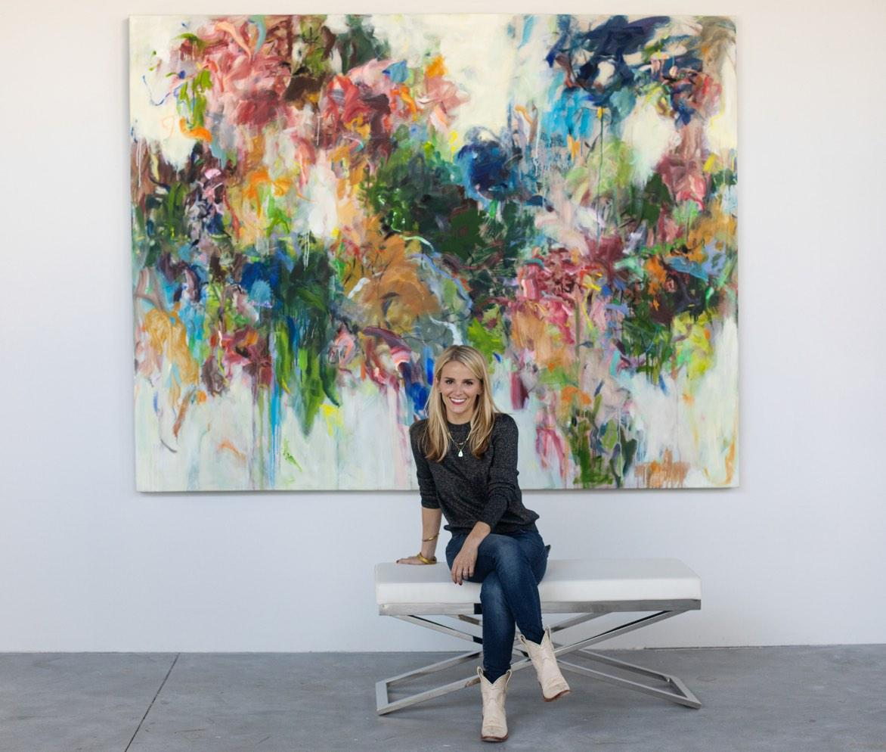
Carly Allen-Martin with one of her paintings. Photo credit : Nicole Franco.

About Carly Allen-Martin
Carly Allen-Martin is an acclaimed contemporary artist most well known for her use of color and themes of perseverance. From studying at Santa Reperata International School of Art in Florence, Italy, The European Academy of Art in Trier, Germany, Aoyama Gakiun University in Tokyo, Japan, Allen-Martin’s pursuit of an education in art has led her around the world, as well as given her international collectors.

About Artspace111
Located in downtown Fort Worth, Texas, Artspace111 specializes in the exhibition of Contemporary Texas Art. In 1980, twin brothers Daniel and Dennis Blagg established Artspace111, converting a historic 1911 building into artist studios and a small gallery space in order to support and celebrate the work of local artists. In 2007, Margery Gossett and William Grella became the Owner/Directors of Artspace111 and further developed the gallery into a celebrated and distinguished 3,000 square foot art gallery. In addition to the year-round schedule of solo and group exhibitions, Artspace111 designs corporate and private art collections for clients throughout the country and hosts special events in its distinctive gallery and sculpture gardens. Artspace111 is dedicated to making contemporary art approachable to individuals of all ages.

For additional information, images, or interviews, please contact:

Ariel Davis

ariel@artspace111.com

