Artspace111 Announces New Exhibition and New Exhibition Series

The Jane Series | New Works by Layla Luna
Solo Solo | Martha Elena Flores

May 13 - June 26, 2021
Opening Reception May 13, 2021, 5-8 PM
______________________________________________________________________________

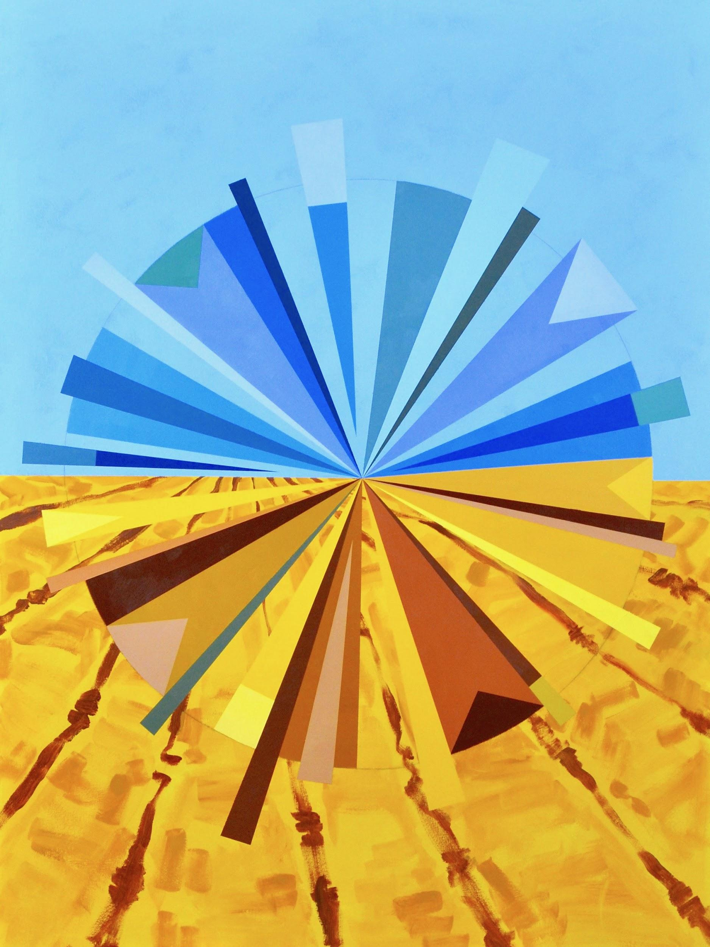
M. Poppins, 2020, Acrylic on canvas. 48 x 36.”
The Jane Series

Artspace111 is excited to introduce The Jane Series by Layla Luna. Through abstracted colorful geometric paintings, Luna uses the concept of pie charts and mud pies to address the over-analysis of our daily lives in the digital age. Luna compares the pie chart shape to the shape of the nostalgic childhood mud pie; a symbol of the simplicity of life, childhood freedom, and creating with abandon.

Through many facets in the work, Luna subtly hints at female artist empowerment. The Jane Series references her inherited middle name, Jane; a name she shares with her cousin, maternal grandmother, mother, and daughter. This name acts as a link between the stories of all the women in her family. Luna completes her work with titles referencing heroines from childhood stories shared by her family, thus transforming the series into an anthropomorphic work. Each of the paintings becomes an individual courageous “Jane.”

“The idea started with the pie chart and how we as artists are inundated with what success is and how to achieve it. The mud pies, childhood story heroines, and my family name are ways of taking control over my own path to success. Kiddos make with abandon - The Jane Series is my way to reclaim that confidence.” - Layla Luna

About Layla Luna

A defining aspect of Layla Luna’s studio practice is making work in series. Each body of work may differ from one to the next in regard to materials used and specific themes, but two recurring interests serve as a common link: our interaction with nature and the attachments we place on objects, spaces, and architecture. The idea of home, as well as its physical structure, has come to embody these interests.

Luna was born in Fort Worth, Texas in 1975. She received an MFA in Painting from Texas Christian University in 2016 and a BFA in Painting from Arizona State University in 2008. She studied at Massey University in Wellington, New Zealand where she obtained a Postgraduate Diploma in Fine Art in 2011. Artist-in-residence programs around the country have played a large role in feeding her need to explore and make work in new environments. Currently, Luna lives and works in Fort Worth, Texas.

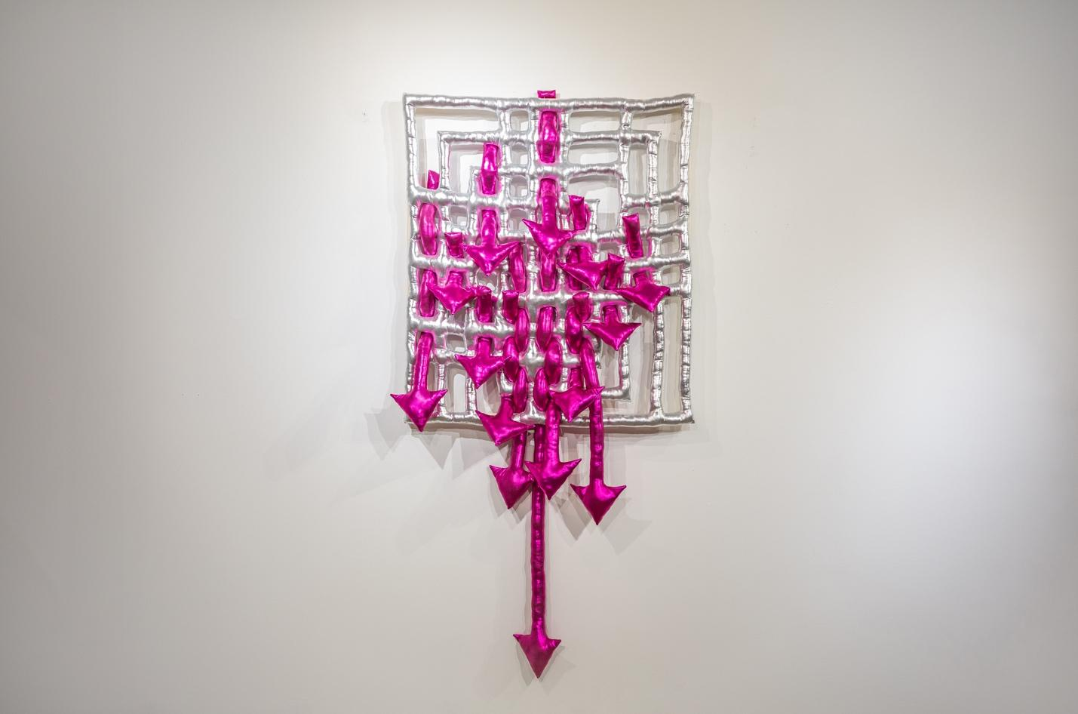
-a,a,c, (mi melancholia), 2021, Knit and filling. 3 x 3 x 4.”

Solo Solo | Martha Elena Flores

As the recipient of the Top Prize in the 7th Annual Texas Juried exhibition, Martha Elena Flores was awarded an opportunity to exhibit once again with Artspace111. In 2021, Artspace111 is excited to present a showcase of Flores’ intricate soft sculptures in the newly defined Solo Solo Exhibition series. Martha Elena Flores is the inaugural artist in this showcase, which aims to provide solo show opportunities to rising Texas artists.

Martha Elena Flores says this about her artwork: “The breadth of my work explores the idea of getting lost in translation. The work begins as a phrase that is converted using the Wingdings 3 font. The font does two things: One, it serves as a filter so that the viewer does not recognize the wording- only the form. It is the bridge between two sets of language and identities. I am torn in two. My native tongue is broken and limited while my English is still incomplete. Wingdings 3 helps me to create a new sense of self. One that only I can understand and manipulate. Two, it allows me to repeat motifs that can be designed and redesigned endlessly. I am interested in the visual representation of language. The content of the words influences the composition, color, and size of the work.”

About Martha Elena Flores

Martha Elena was born in Cerritos, Mexico, and raised in Rio Grande Valley, Texas. Elena attended and graduated from the University of Texas Pan American (now UTRGV) with a BFA. She now resides in Fort Worth, Texas. Elena is a Multi-disciplinary artist, and she is currently exploring and evolving Soft Sculpture.

About Solo Solo

Solo Solo is a newly defined exhibition series for Artspace111 that aims to provide solo show opportunities to rising Texas artists. The series provides an opportunity for early-career artists to share their artwork in a focused exhibition, providing patrons a rounded view of the artist’s vision and body of work. Artists are selected by invitation or as part of the Top Prize award for the Texas Juried Exhibition. This series will be revisited at least twice each year in order to support the careers of emerging talent.

About Artspace111
Located in downtown Fort Worth, Texas, Artspace111 specializes in the exhibition of Contemporary Texas Art. In 1980, twin brothers Daniel and Dennis Blagg established Artspace111, converting a historic 1911 building into artist studios and a small gallery space in order to support and celebrate the work of local artists. In 2007, Margery Gossett and William Grella became the Owner/Directors of Artspace111 and further developed the gallery into a celebrated and distinguished 3,000 square foot art gallery. In addition to the year-round schedule of solo and group exhibitions, Artspace111 designs corporate and private art collections for clients throughout the country and hosts special events in its distinctive gallery and sculpture gardens. Artspace111 is dedicated to making contemporary art approachable to individuals of all ages.

